

**Fundamentals of Databases (CBIO204)**

**Summer, 2025**

**Clinic Management System**

|  |  |
| --- | --- |
| **Student Name** | **ID** |
| **Bishoy Abdelshehid** | **221001760** |
| **Peter Emad** | **221000484** |
| **Ahmed Elshall** | **221001566** |
| **Salma Sabry** | **231000937** |
|  |  |

**Instructor Name: DrMohamed Elsayeh**

1. **Introduction**

This SQL script creates a Clinic management System with tables designed to handle the scheduling of appointments and the management of patient medical history. The system supports multiple departments, each associated with various clinics and doctors. It records key information about patients, doctors, appointments, clinics, and departments. Using a relational database model, the system ensures data integrity and enables efficient retrieval of medical and administrative information.

1. **Database Sche ma**

* Department: Department ID, name, and clinics related to this department.
* Clinic: Clinic ID, name, address, and department.
* Doctor: Doctor ID, name, phone number, address, and department.
* Patient: patient ID, name, phone number, address, birth date, job.
* Appointment: appointment ID, date, patient, doctor, start time, end time, cost, status (scheduled, in progress, postponed), and patient diagnosis.

1. **Relationships**

-one to many relationship between the doctor and the appointment, each doctor can have many appointments

- one to many relationship between the department and the doctors, each department contains of many doctors

- one to many relationship between department and clinics, each department have many clinics

- one to many relationship between patient and appointment, each patient can have multiple appointments

1. **SQL Queries**

-List the names of patients who were diagnosed with fatty liver in the last year :This query selects the names of patients from the Patient table.

It uses a subquery to find PatientIDs from the Appointment table where the diagnosis is 'Fatty liver' and the appointment date is within the last year.

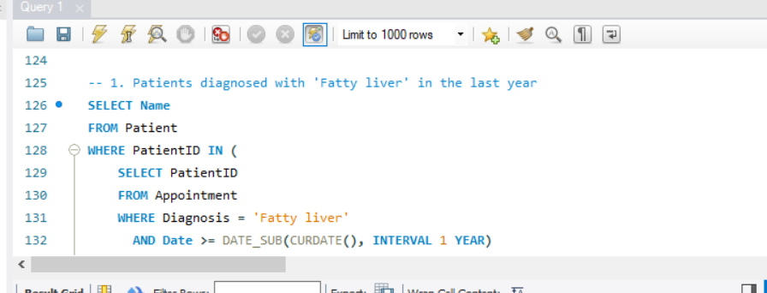

-List the addresses of cardiology clinics: This query retrieves the addresses of clinics from the Clinic table.

It uses a subquery to find the DepartmentID for the 'Cardiology' department and then matches it with the DepartmentID in the Clinic table.

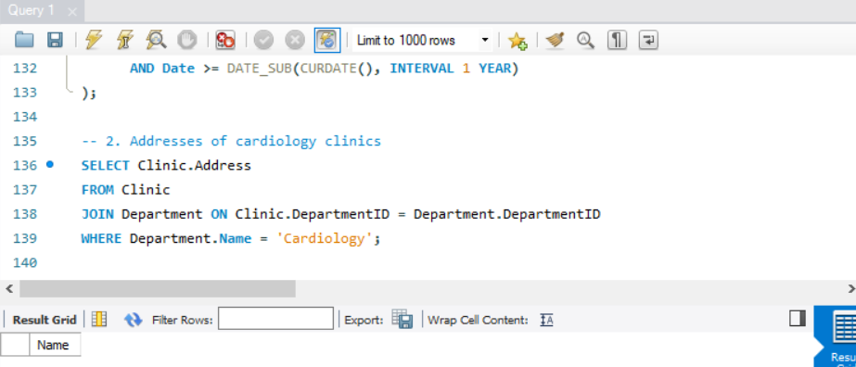

-List the total money paid : this query calculates the total money paid by the patient with PatientID 12527.

It uses the SUM function to add up the Cost of all appointments for this patient where the appointment date is within the last three years a patient whose ID is 12527 in the last three years:

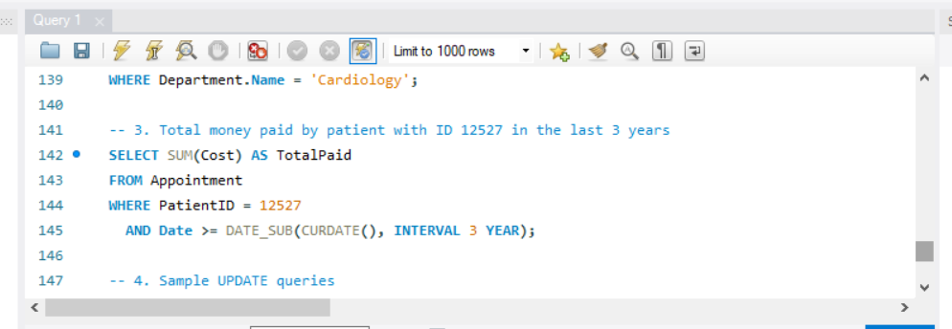

1. **Triggers**

Update Doctor's Department

This query changes the department of a doctor with a specific DoctorID

Update Patient Information

This query updates the address and phone number of a patient with a specific PatientID

1. **Data Population**

The Clinic_System database with initial test data. This includes creating the necessary tables and inserting test records for each table. Department Table: Stores the different departments available in the clinic.

Clinic Table: Stores information about different clinics including the department they belong to.

Doctor Table: Stores information about doctors and the department they are associated with.

Patient Table: Stores information about patients.

Appointment Table: Stores appointment details, including the patient, doctor, and related information.

1. **CRUD Operations**

Create Operations: Used to add new records to the tables.

Read Operations: Used to retrieve data from the tables.

Update Operations: Used to modify existing records in the tables.

Delete Operations: Used to remove records from the tables

Insert a New Department, Insert a New Clinic, Insert a New Doctor, Insert a New Patient, Insert a New Appointment

Update a Patient's Phone Number, Update a Doctor's Address

1. **ER diagram.**

1. **logical design**

